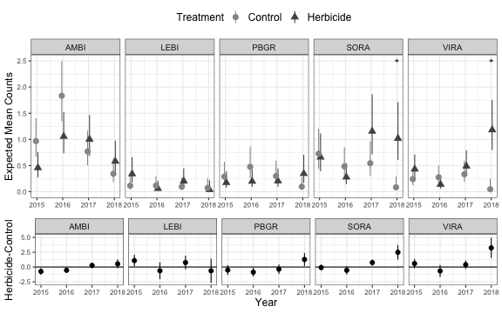

Figure 3.Expected mean marshbird counts (upper panel; error bars represent 95% confidence interval) within years 2015 to 2018 in 9 study sites that included both treatment (areas treated with herbicide) and control (areas not treated with herbicide) survey locations in northwestern Minnesota, USA, and the difference between expected mean marshbird counts (lower panel) for 5 species of marshbirds [American bittern (AMBI), least bittern (LEBI), pied-billed grebe (PBGR), sora (SORA), and Virginia rail (VIRA)]. We evaluated whether herbicide application affected mean marshbird counts by conducting surveys during spring breeding seasons at treatment and control survey locations and evaluated change in number of detections from the spring before to 3 springs after herbicide application (2015 – 2018). Statistical results are pairwise comparisons between the mean expected counts at control and treatment survey locations within study sites based on a generalized linear mixed model with plot as a random effect and a treatment-by-year interaction that was run for each individual species (log link, Poisson family). Asterisks represent significant treatment effects at *P* < 0.05.